Homework Problem Set D Submission Form

# Overview

|  |  |
| --- | --- |
| Your Name | Sana Khan |
| Your SU Email | Skhan53@syr.edu |

# Instructions

Put your name and SU email at the top. Answer these questions all from the lab. When asked to include screenshots, please follow the screenshot guidelines from the first homework.

Remember as you complete the homework that it is not only about getting it right/correct. We will discuss the answers in class so it’s important to articulate anything you would like to contribute to the discussion in your answer:

* If you feel the question is vague, include any assumptions you've made.
* If you feel the answer requires interpretation or justification provide it.
* If you do not know the answer to the question, articulate what you tried and how you are stuck.
* Highlight any doubts or questions you would like me to review.

This how you receive credit for answering questions which might not be correct. In addition, you must complete the reflection portion of the homework assignment for full credit. Since most answers will be similar this is an important part of your individual submission.

Complete Part II of this document first, then go back and complete the Reflection in Part I.

# Part I: Reflection

Use this section to reflect on your learning. To achieve the highest grade on the assignment, you must be as descriptive and personal as possible with your reflection.

1. As you completed this assignment, identify what you learned.
2. What barriers or challenges did you encounter while completing this assignment?
3. How prepared were you to complete this assignment? What can you do to be better prepared?
4. Rate your comfort level with this week’s material. Use the rubric provided.

4 ==> I understand this material and can explain it to others.  
3 ==> I understand this material.  
2 ==> I somewhat understand the material but sometimes need guidance from others.  
1 ==> I understand very little of this material and need extra help.

# Part II: Questions

Paste your answers to the exercises found in the lab document. Make sure to include your NetID in any screenshots you provide. If the question asks for commands, only include those commands that are necessary to complete the tasks. Number each answer.

1. Connect to the Minio client. Create an alias to your Minio server, named **ms**. Create a bucket **labd**. Inside the bucket, create folders **iplookup** and **logs**. Copy the three log files from **/datasets/clickstream** to the Minio **logs** folder. Copy **iplookup.json** to the **iplookup** folder.

When you are finished you should have the following structure. Provide a list of commands necessary to complete this task. And include screenshots to show the files are there.

ms

|

|__ labd

|

|__ iplookup

| |

| |__ iplookup.json

|

|__logs

|

|__ u_ex160211.log, u_ex160212.log, u_ex160213.log

**mc alias set minio** [**http://minio:9000**](http://minio:9000) **minio SU2orange!**

**mc mb minio/labd**

**mc mb minio/labd/logs**

**mc mb minio/labd/iplookup**

**mc cp /home/jovyan/datasets/clickstream/iplookup.json minio/labd/iplookup**

**mc cp /home/jovyan/datasets/clickstream/u_ex160211.log minio/labd/logs**

**mc cp /home/jovyan/datasets/clickstream/u_ex160212.log minio/labd/logs**

**mc cp /home/jovyan/datasets/clickstream/u_ex160213.log minio/labd/logs**

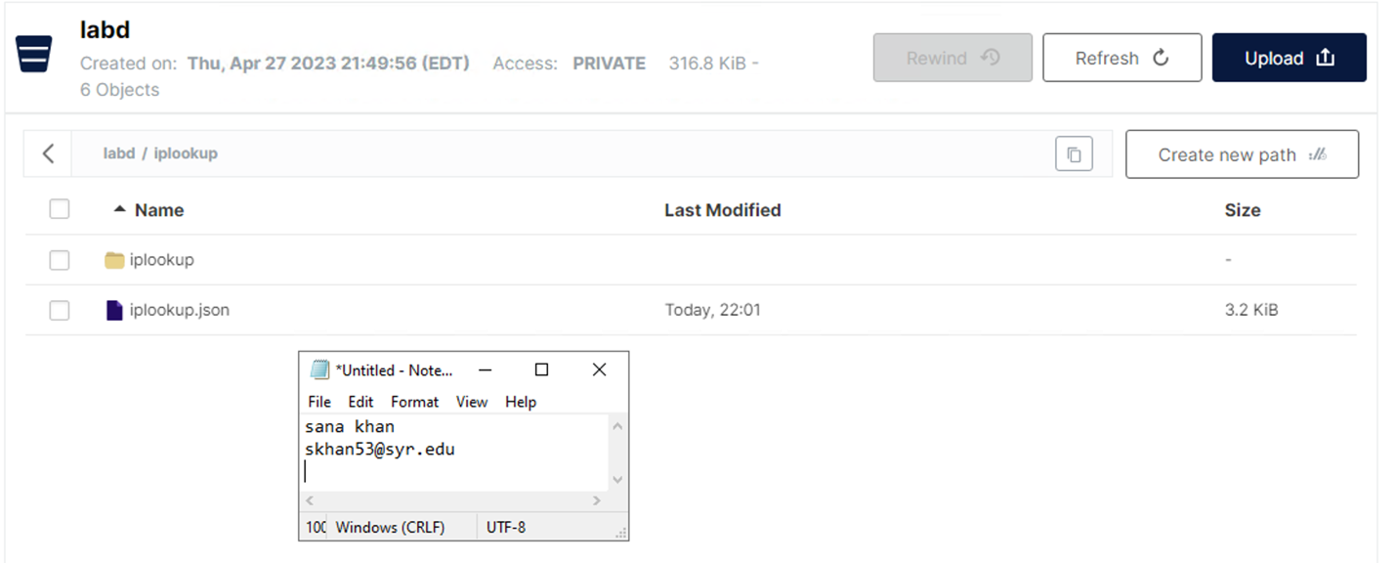

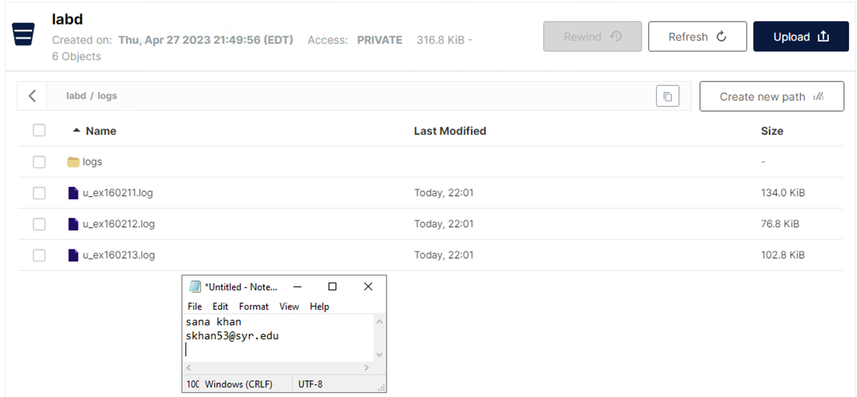

1. Create a new Spark notebook called **labd.ipynb**. Write (or copy and edit) Spark code to set up the Spark session. Make sure your Spark session supports Minio access and include the **hadoop-aws** Spark Jar package. Provide a screenshot of your code and the output.   
   NOTE: You do not need Hive support.

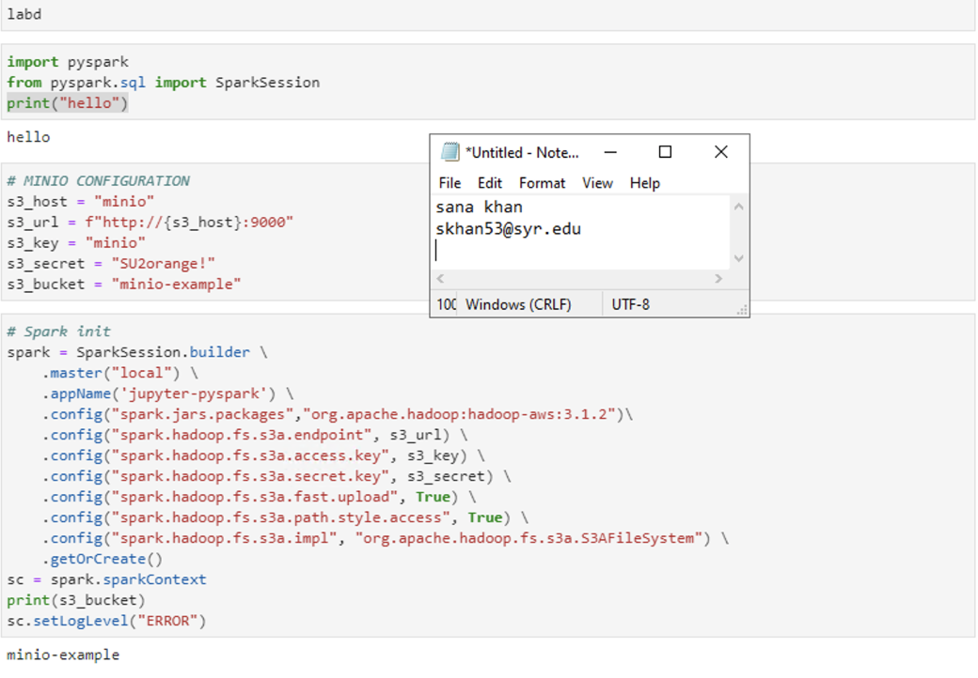

1. Write Spark code to load logs from Minio **labd/logs** into a dataframe **logs1** using **spark.read.text**. Print the schema and show 10 rows from the DataFrame. Screenshot the code and output.   
   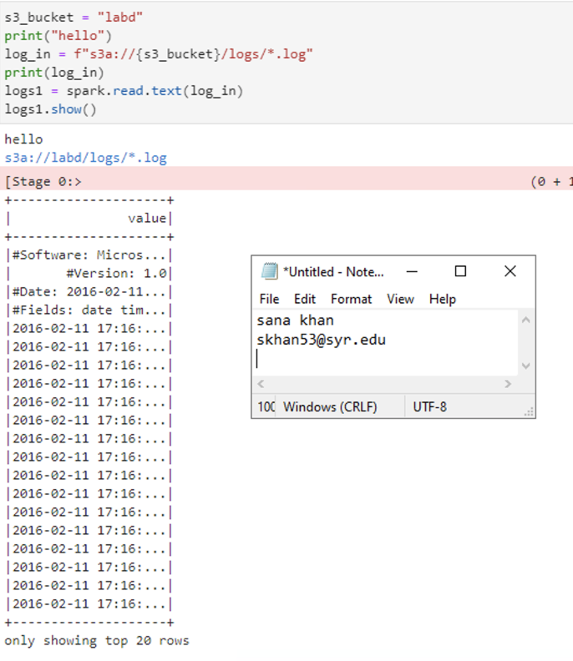
2. We need to remove the rows with **#** in front of them, as these are comments in the web server log files. Use the **filter()** function to do this, and save the results into DataFrame **logs2**. Show the code and output in your screenshot.  
   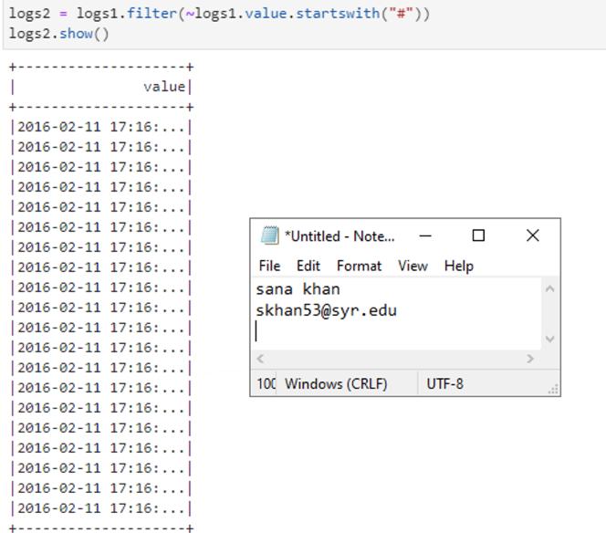
3. Write back your **logs2** to Minio. Use the **text** format and call the file **logs-no-header**.Include a screenshot of the code and output.

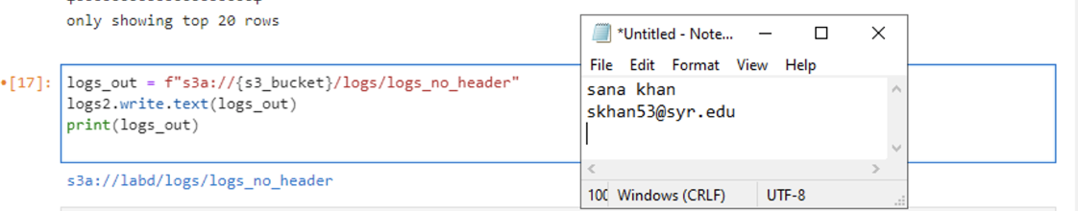

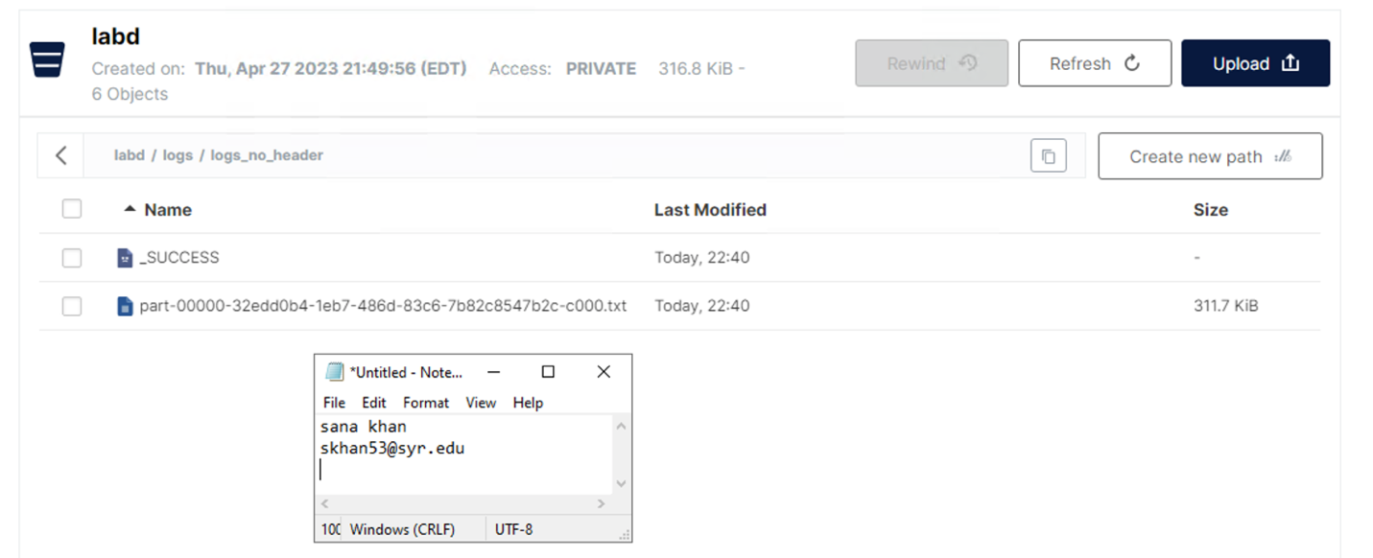

1. Read in the **logs-no-header**, this time using **csv** to delimit on a space into **logs3**. Add headers (date, time, serverip, method, uri, querystring, port, username, clientip, useragent, referrer, statuscode), and provide an output of the schema and the first couple of rows from the dataframe itself in the screenshot.   
     
   Here is what the DataFrame should look like:  
   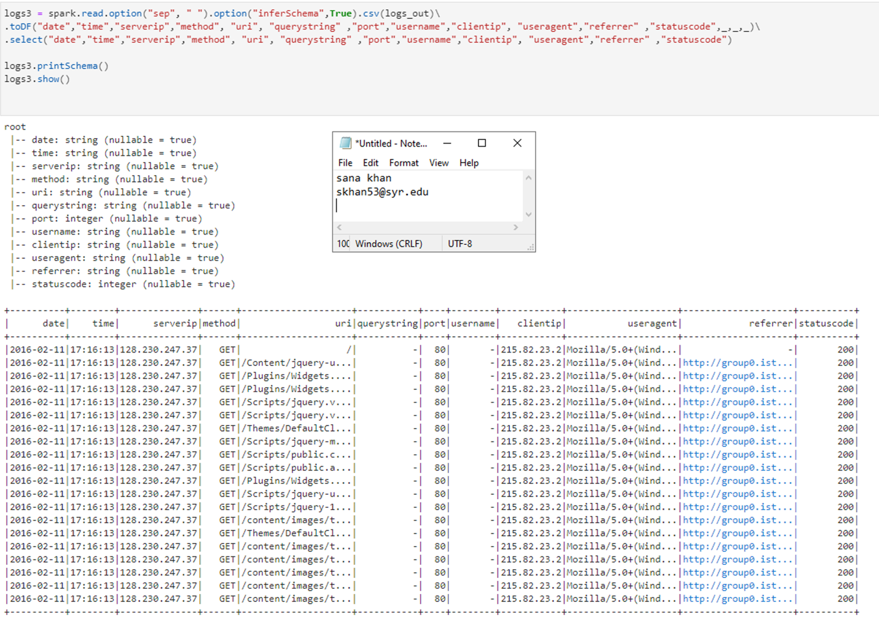
2. Let's handle the IP address lookup data. Write Spark code to load the **iplookup.json** file from Minio into the DataFrame **ips1**. Show the first 10 rows and print the schema for a screenshot to include code and output.

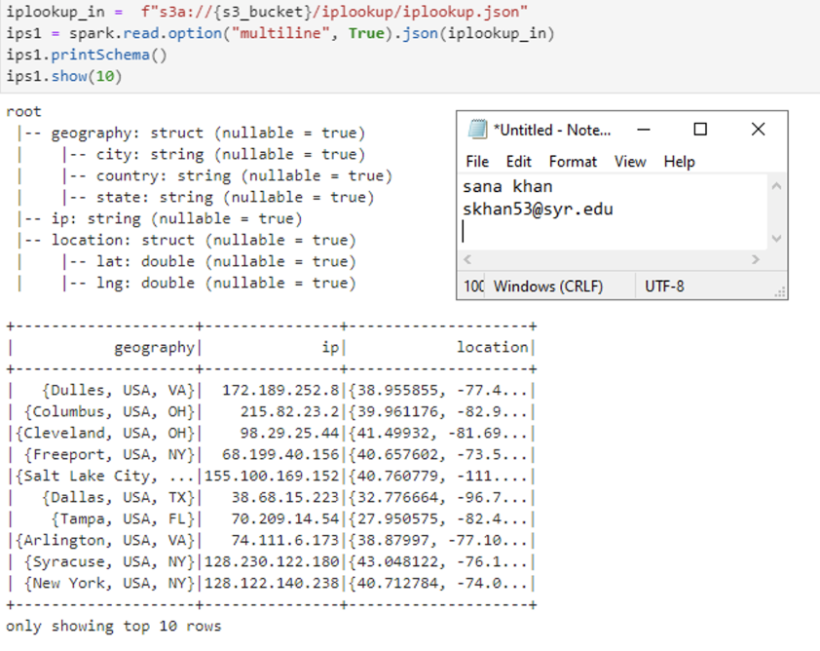

1. We need to flatten the nested JSON data. Use the **select()** function with dot notation to do this, saving the DataFrame as **ips2**. Provide a screenshot of the schema and output of the first few rows.

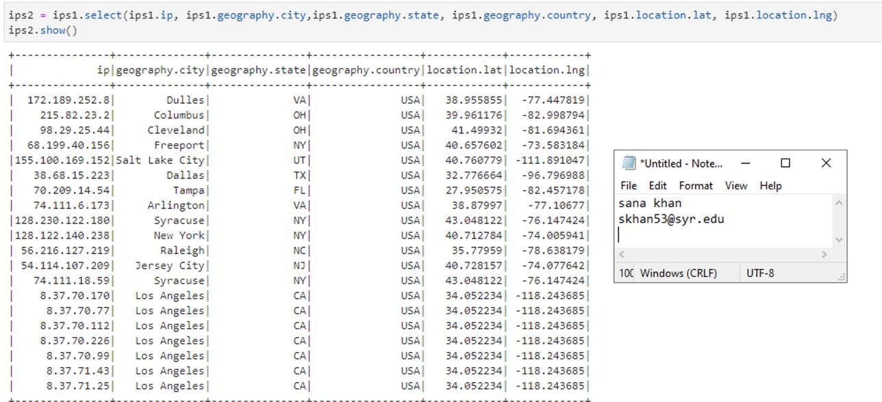

1. Now join the two DataFrames together on their business key, making the new DataFrame **comb1**. Provide a schema and sample of the first few rows in your screenshot.

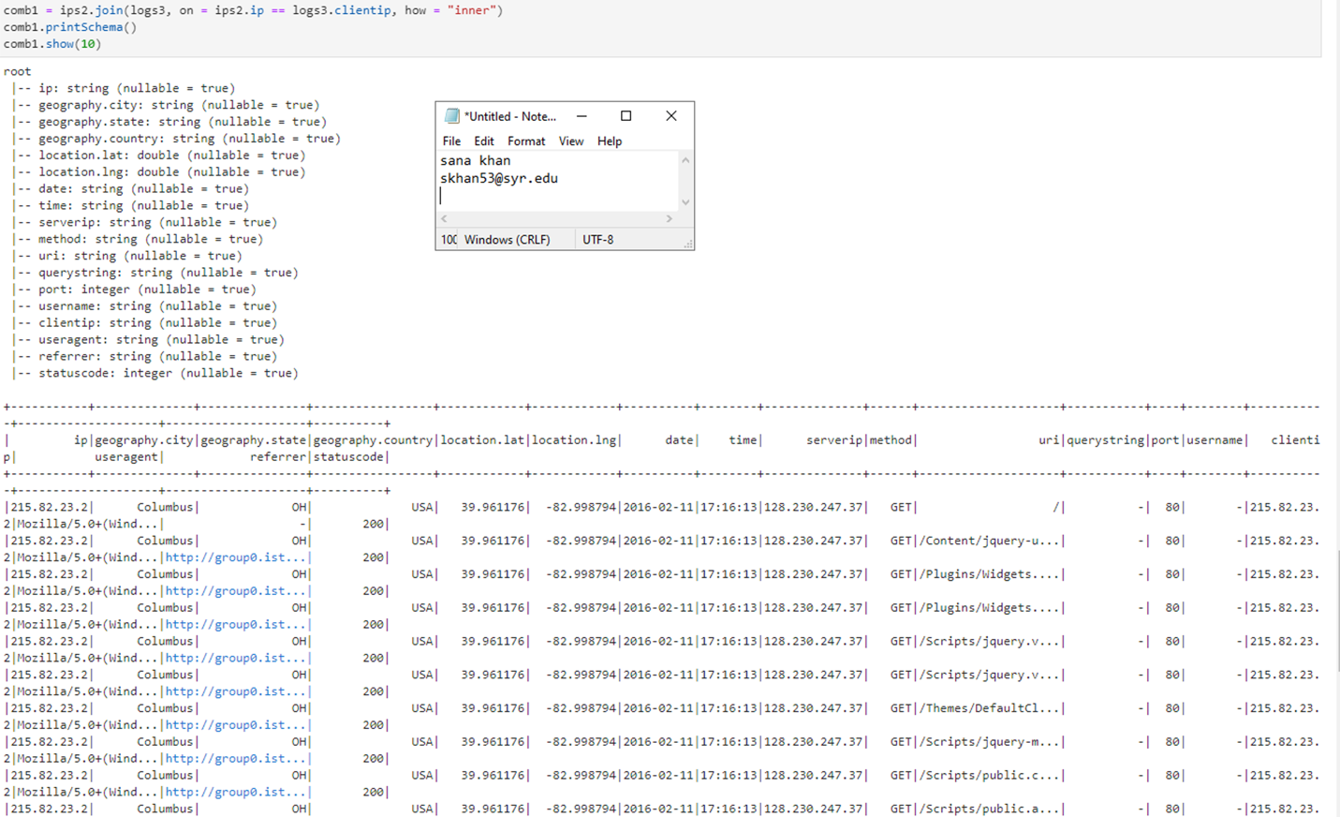

1. Write the **comb1** DataFrame in **parquet** format back to Minio in the folder **cleaned-logs**. Again, show evidence the code ran and the file was created.

